Research report:
Addressing the Human Rights Situation in Yemen
Guiding question:
How are the Human Rights of the Yemini violated and what can we do to solve this?

What is the situation in Yemen?

Yemen faces its biggest crisis in decades with the overthrow of its government by the Houthis, a movement backed by Iran. As the Houthis captured the capital of Sana’s and advanced south toward the Gulf of Aden in March 2015, a Saudi-led coalition launched an air campaign to reinstate Yemen’s internationally recognized government.

These developments have derailed a political transition following the uprising in 2011 against the longtime President Ali Abdullah Saleh. In this transition period, a side branch of al-Qaeda found new opportunities to capture territory. Meanwhile the Houthi advance and Saudi intervention have provoked a humanitarian crisis, causing many Yemenis to flee by land and sea.

The armed conflict in Yemen has resulted in the largest humanitarian crisis in the world; parties to the conflict have killed and injured thousands of Yemeni civilians. According to the Yemen Data Project, more than 17,500 civilians were killed and injured since 2015, and a quarter of all civilians killed in air raids were women and children. More than 20 million people in Yemen are experiencing food insecurity; 10 million of them are at risk of famine.
Since March 2015, Saudi Arabia and the United Arab Emirates have led a coalition of states in Yemen against Houthi forces that, in alliance with former Yemeni President Ali Abdullah Saleh, took over Yemen’s capital, Sanaa, in September 2014.
Over the past year, these alliances have fractured. Houthi forces, which still control much of northern and central Yemen, killed Saleh after clashes in December 2017. In southern Yemen, Saudi Arabia and the UAE have backed rival Yemeni groups, in which the Saudi-supported Yemeni government led by President Abdu Rabbu Mansour Hadi and the UAE-backed Southern Transitional Council.
In August 2019, clashes occurred between Yemeni government and STC forces, with the UAE carrying out airstrikes in support of the STC. Across the country, civilians suffer from a lack of basic services, a spiraling economic crisis, abusive local security forces, and broken governance, health, education, and judicial systems.
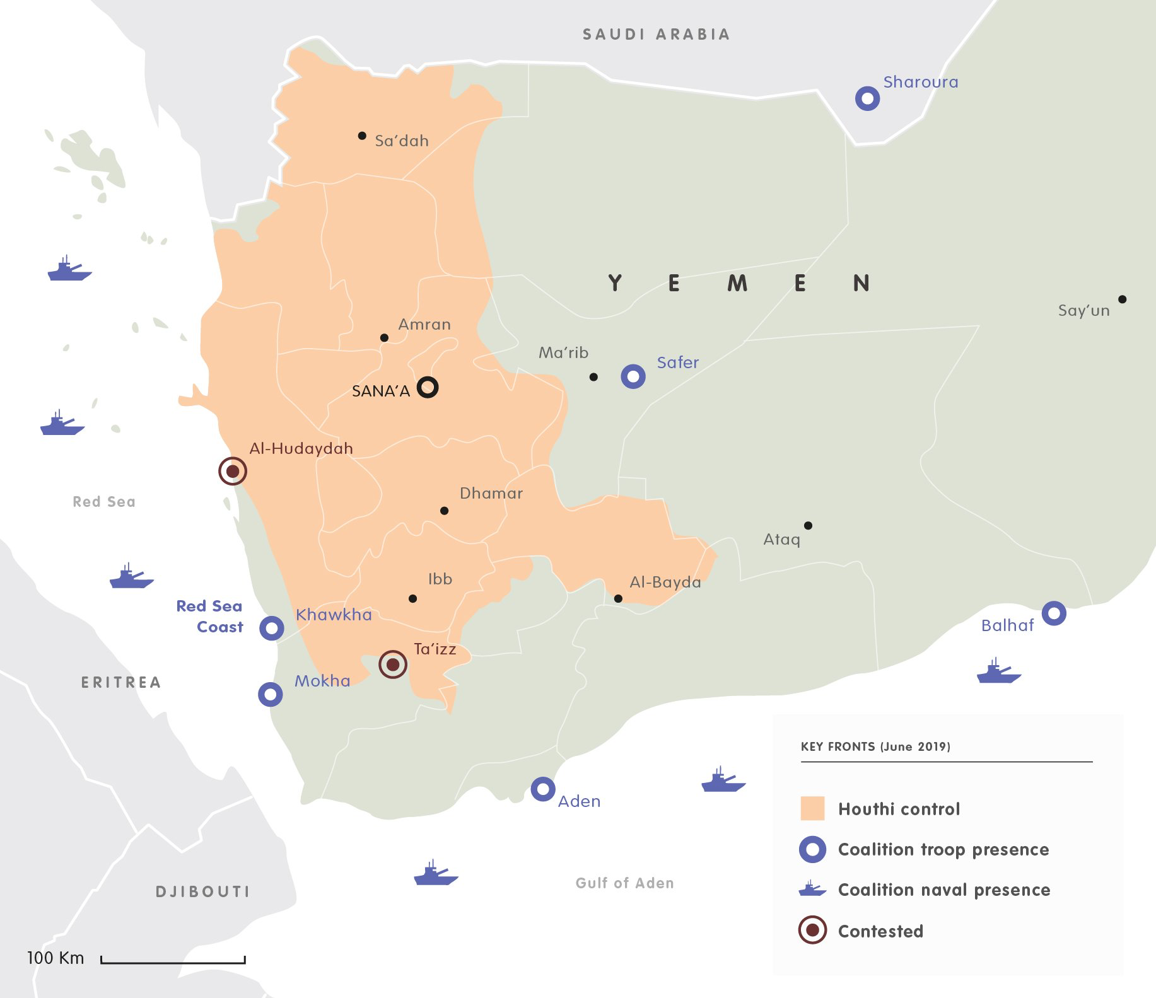
Yemen’s economy, already fragile prior to the conflict, has been gravely affected. Hundreds of thousands of families no longer have a steady source of income, and many public servants have not received a regular salary in several years. The country’s broken economy has worsened the humanitarian crisis.
Coalition and Houthi forces have harassed, threatened, and attacked Yemeni activists and journalists. Houthi forces, government-affiliated forces, and the UAE and UAE-backed Yemeni forces have arbitrarily detained and forcibly disappeared scores of people. Houthi forces have taken hostages.
Since March 2015, the coalition has conducted numerous indiscriminate and disproportionate airstrikes killing thousands of civilians and hitting civilian structures in violation of the laws of war, using munitions sold by the United States, United Kingdom, and others. Houthi forces have used banned antipersonnel landmines, recruited children, and fired artillery indiscriminately into cities such as Taizz, killing and wounding civilians, and launched indiscriminate ballistic missiles into Saudi Arabia.
Unlawful airstrikes
The Human Rights Watch organisation has documented at least 90 apparently unlawful Saudi-led coalition airstrikes, including deadly attacks on Yemeni fishing boats that have killed dozens and appeared to be deliberate attacks on civilians and civilian objects in violation of the laws of war. At time of writing, according to the Yemen Data Project, the Saudi-led coalition has conducted more than 20,100 airstrikes on Yemen since the war began, an average of 12 attacks a day. The coalition has bombed hospitals, school buses, markets, mosques, farms, bridges, factories, and detention centers.

In August 2019, the Saudi-led coalition carried out multiple airstrikes on a Houthi detention center, killing and wounding at least 200 people. The attack was the single deadliest attack since the war began in 2015. Human Rights Watch has documented at least five deadly attacks by Saudi-led coalition naval forces on Yemeni fishing boats since 2018, killing at least 47 Yemeni fishermen, including seven children.

Houthi forces have repeatedly fired artillery indiscriminately into Yemeni cities such as Taizz and Hodeida, as well as launched indiscriminate ballistic missiles into Saudi Arabia, including Riyadh’s international airport. Some of these attacks may amount to war crimes.

Children in Yemen

Since September 2014, all parties to the conflict have used child soldiers under 18, including some under the age of 15, according to a 2019 UN Group of Eminent International and Regional Experts on Yemen report in 2019. According to the secretary general, out of 3,034 children recruited throughout the war in Yemen, 1,940—64 percent—were recruited by the Houthis.

In July, the UN secretary-general released his annual list for violations against children in armed conflict during 2018. The list detailed that 729 children were killed or injured by Saudi-led coalition, 398 children were killed or injured by the Houthis, and the Yemeni government forces were responsible for 58 child casualties.

Although the secretary-general listed the Saudi Arabia-led coalition in Yemen, he once again included the coalition in a category of parties taking steps to improve, despite overwhelming evidence that coalition forces killed and harmed children on a large scale in 2018.

Unlawful inprisonment

Houthi forces, the Yemeni government, the UAE, Saudi Arabia, and different UAE and Saudi-backed Yemeni armed groups have arbitrarily detained people, including children, abused detainees and held them in poor conditions, and abducted or forcibly disappeared people perceived to be political opponents or security threats.

The UN Group of Eminent Experts on Yemen found that UAE and UAE-backed forces practiced arbitrary detention and torture, including sexual violence, in detention facilities they controlled. The detainees subjected to abuse included suspected members of the Islamic State and Al-Qaeda in the Arabian Peninsula, according to investigative media and human rights campaigners’ reports.

Since late 2014, Human Rights Watch has documented dozens of cases of the Houthis carrying out arbitrary and abusive detention, as well as enforced disappearances. Houthi officials have also used torture and other ill-treatment. Former detainees described Houthi officers beating them with iron rods and rifles and being hung from walls with their arms shackled behind them.

Mothers, sisters, and daughters of abducted men have demonstrated in front of prisons across major Yemeni cities, searching for their kidnapped sons, fathers, brothers, and other male relatives, organized under a group named "Mothers of Abductees Association." The association reported that there are 3,478 disappearance cases, at least 128 of those kidnapped have been killed.

